What is Modeling and Simulation?
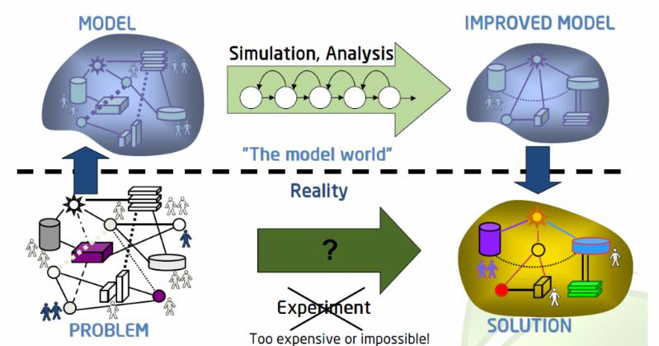

Simulation modeling is the capability to leverage analytics and digital tools to help answer “what-if” questions in the business context. These tools help you evaluate the impact of business decisions on your business processes and may help you select the most optimal decision. An example may be manufacturing scheduling. A simulation modeling tool can help you evaluate the impact of various scheduling approaches on manufacturing cycle time.
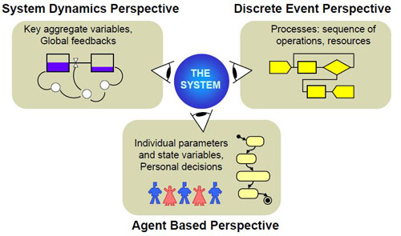
Simulation tools often help evaluate recommendations from other analytics approaches like optimization, without implementing those recommendations in the real-world. The three most widely used process simulation modeling types are:
- System dynamics
- Discrete event modeling
- Agent-based modeling

Simulation Technologies Available in the SAP World
Process simulation modeling tools have been leveraged extensively in SAP technology ecosystem. An example is SIMUL8, which is a flow simulation program that can help you visualize your process flows, understand the bottlenecks, and evaluate the impact of change in parameters on the process. As far as non-SAP process simulation modeling solutions are concerned, all leading simulation software tools like AnyLogic and Simio integrate well with SAP environments.
Key Considerations:
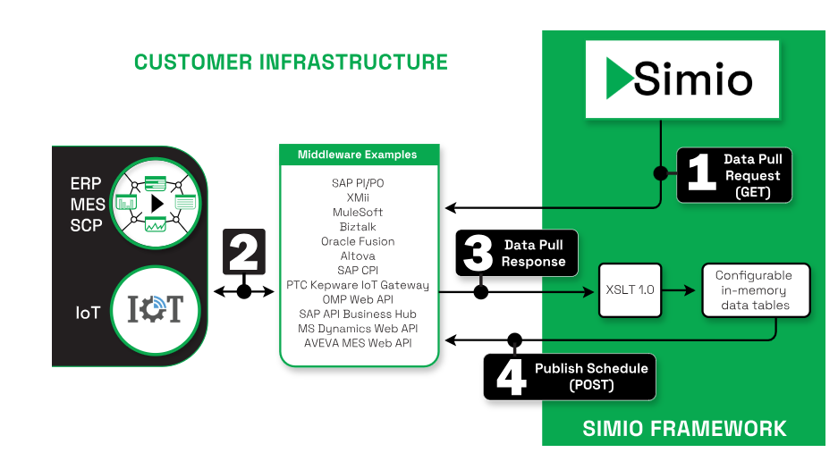
Understand the methods and process alignment. The choice of method that should be used is based on the system being modeled and the purpose of the model. It is therefore critical to understand which specific simulation method will be a good fit. This is important from the perspective of tools being leveraged since some tools have more coverage and use cases in certain methods.
Define the level of abstraction of the process model. This is where you define how detailed your model needs to be. Remember that this depends on the modeling objective. As an example, if you are trying to gain an understanding of the cycle time of a product flow across the supply chain, you do not need to model individual processes within a manufacturing location. But if your simulation model is going to focus on the impact of changeover time on a manufacturing line, you may have to model the entire line flow in detail.
Think about integration with tools like business process intelligence (BPI). Note that the majority of BPI tools already do a good job of capturing process flow and building a model from that flow. Not all of them, however, offer simulation capabilities and those that do may not have the features a standalone pure simulation tool or module may offer. By strategically integrating a simulation tool with a BPI tool, you can create a solution that takes your process management capabilities even further.

